Lab No 9
Design of a Light switch
Objective: Build a light switch controller such that when the push button is pressed the light if “off” turns “on” and if “on” turns “off”.
Block Diagram:The top level block diagram is shown in the following figure. The second diagram is a more detailed view of the top level diagram. Synchronizer circuit is used to avoid the metastability problem which arises when synchronous digital system are fed with an asynchronous input. The level to pulse converter is there to convert level input from a push button into a pulse that is high for only one clock cycle. The switch button FSM is actually implementing the state machine for the requirement i-e when the push button is pressed the light if “off” turns “on” and if “on” turns “off”.
I/O connection: Connect the button input to a push button on the S3BOARD and light output to LED.
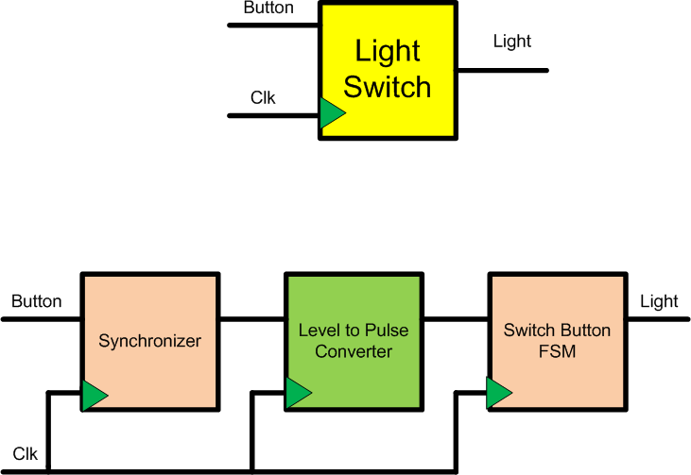
Synchronizer Circuit:

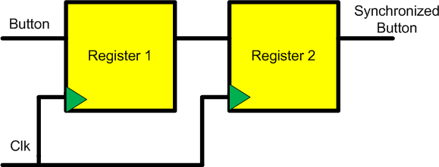

Level to Pulse FSM:

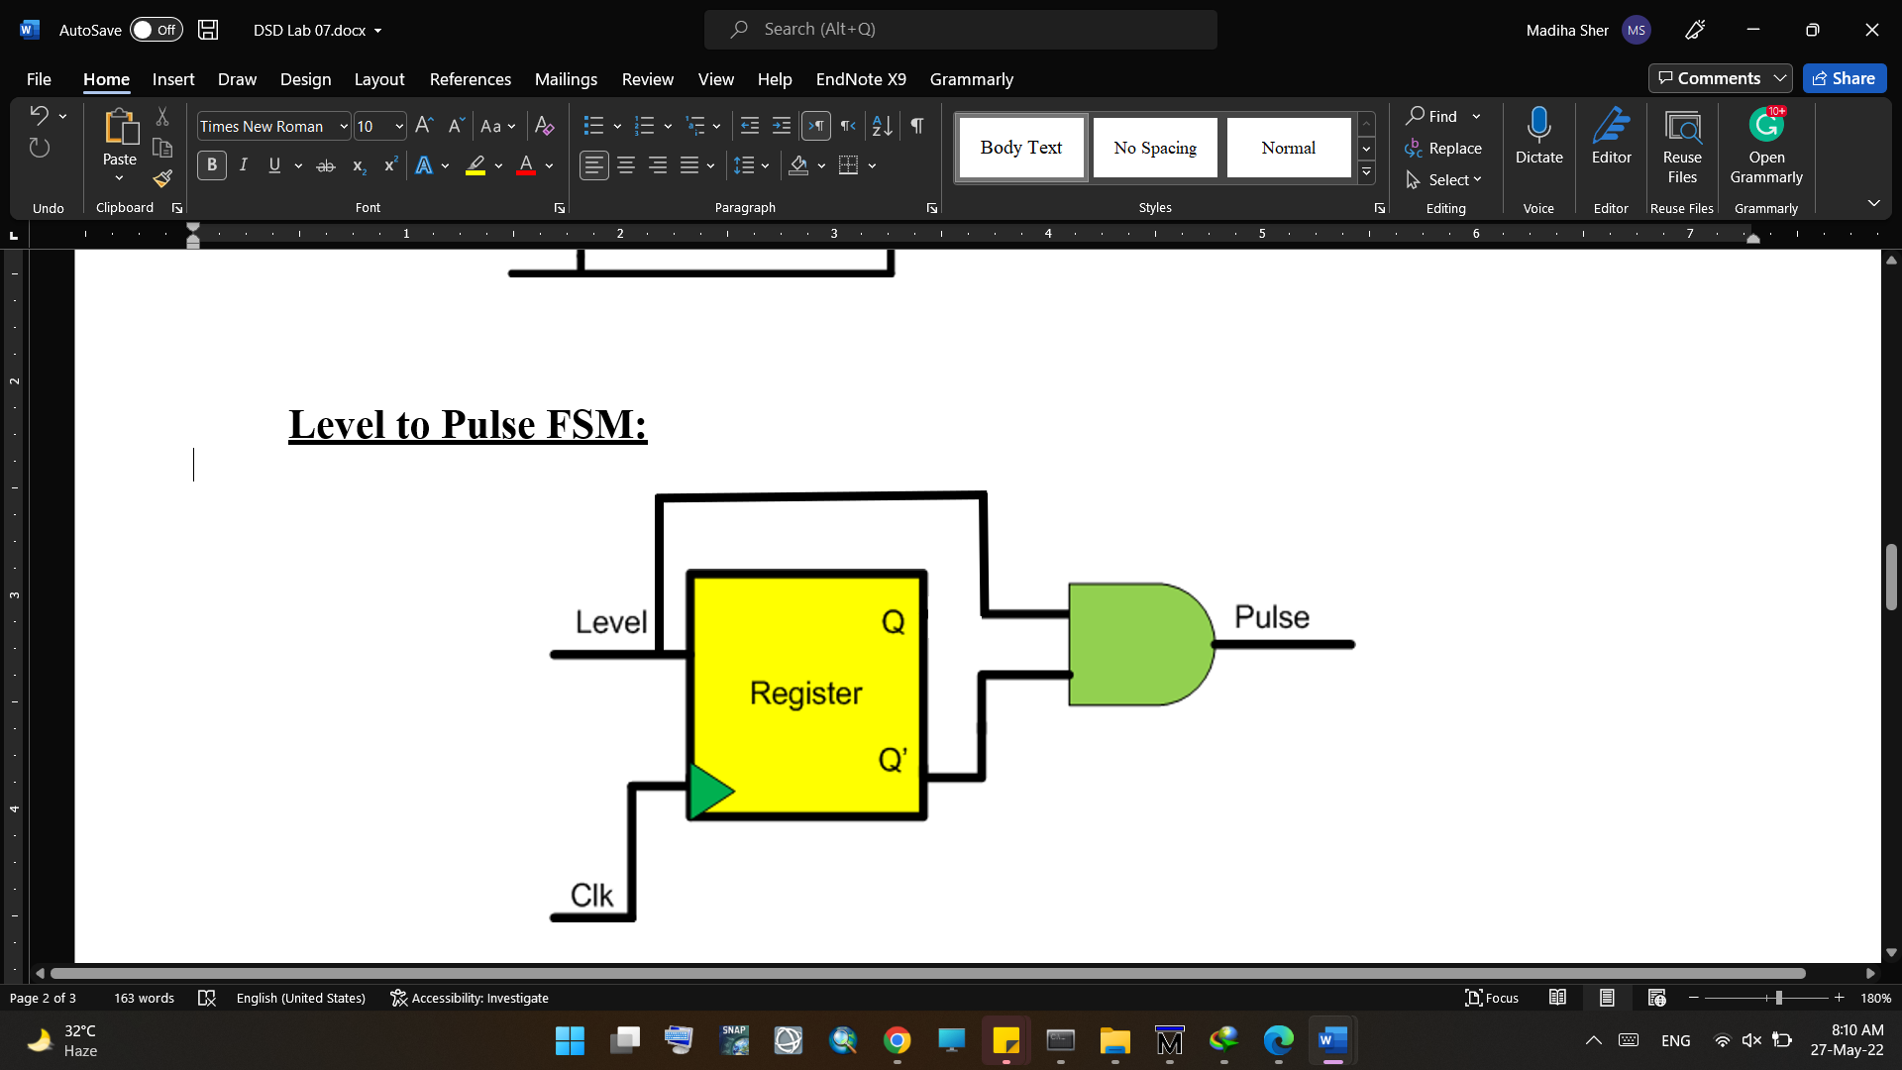

Switch Button FSM:
